DPS Biblical Archeology Study – Teacher’s Guide
7. Archeological Finds that Preserve the Integrity of the Bible
Overview
a. The Dead-Sea Scrolls
b. The Nag Hammadi Library
Discussion Questions
a. The Dead Sea Scrolls
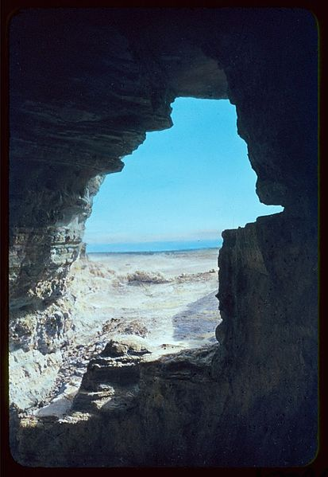
The Dead Sea scrolls consist of roughly 1000 documents, including texts from the Hebrew Bible, discovered between 1947 and 1979 in eleven caves in and around the Wadi Qumran (near the ruins of the ancient settlement of Khirbet Qumran, on the northwest shore of the Dead Sea) in Israel. The texts are of great religious and historical significance, as they include practically the only known surviving copies of Biblical documents made before 100 AD, and preserve evidence of considerable diversity of belief and practice within late Second Temple Judaism.
The scrolls were found in 11 caves, ranging in distance of 125m (Cave 4) to about 1000m (Cave 1) from the settlement at Qumran, located 1km off the northwest shore of the Dead Sea. None of them were found at the actual settlement. It is generally accepted that a Bedouin goat- or sheep-herder by the name of Mohammed Ahmed el-Hamed (nicknamed edh-Dhib, "the wolf") made the first discovery toward the beginning of 1947.
In the most commonly told story the shepherd threw a rock into a cave in an attempt to drive out a missing animal under his care. The shattering sound of pottery drew him into the cave, where he found several ancient jars containing scrolls wrapped in linen. Another theory was that two young boys were looking for a lost goat and came upon some of them.
The significance of the scrolls relates in a large part to field of textual criticism. Before the discovery of the Dead Sea Scrolls, the oldest Hebrew manuscripts of the Bible were Masoretic texts dating to 9th century. The biblical manuscripts found among the Dead Sea Scrolls push that date back to the 2nd century BC. Before the discovery, the oldest Greek manuscripts such as Codex Vaticanus and Codex Sinaiticus were the earliest extant versions of biblical manuscripts. Although a few of the biblical manuscripts found at Qumran differ significantly from the Masoretic text, most do not. The scrolls thus provide new variants and the ability to be more confident of those readings where the Dead Sea manuscripts agree with the Masoretic text or with the early Greek manuscripts.
Further, the sectarian texts among the Dead Sea Scrolls, most of which were previously unknown, offer new light on one form of Judaism practiced during the Second Temple period.
Books: Genesis, Exodus, Leviticus, Numbers, Deuteronomy, 1&2 Samuel, Job, Isaiah, Jeremiah, Ezekiel, Psalms, Minor Prophets, Daniel
Conclusion: the greatest impact that the scrolls have provided is that they confirm a reliable preservation of the Old Testament text over an extended period of time. By extension an argument could be made that the same claim can likely be made for the preservation of the New Testament writings.
b. The Nag Hammadi Library
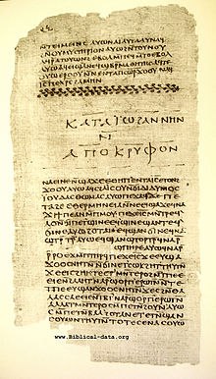
The Nag Hammadi library (popularly known as The Gnostic Gospels) is a collection of early Christian Gnostic texts discovered near the town of Nag Hammâdi in 1945. That year, twelve leather-bound papyrus codices buried in a sealed jar were found by a local peasant named Mohammed Ali Samman. The writings in these codices comprised fifty-two mostly Gnostic tractates (treatises), but they also include three works belonging to the Corpus Hermeticum and a partial translation / alteration of Plato’s Republic. In his "Introduction" to The Nag Hammadi Library in English, James Robinson suggests that these codices may have belonged to a nearby Pachomian monastery, and were buried after Bishop Athanasius condemned the uncritical use of non-canonical books in his Festal Letter of 367 AD.
The contents of the codices were written in Coptic, though the works were probably all translations from Greek. The best-known of these works is probably the Gospel of Thomas, of which the Nag Hammadi codices contain the only complete text.

Case Study from the Nag Hammadi Library:
The Gospel of Thomas as compared to the New Testament Canon
http://gnosis.org/naghamm/gthlamb.html
The Gospel of Thomas may have been excluded from the canon of the New Testament because it was believed not to have been written close to the time of Jesus [not to have been written by apostolic authority or was forged in Thomas' name not to have been used by multiple churches over a wide geographic range to be heretical or unorthodox].
The Gospel of Thomas does not refer to Jesus as "Christ" or "Lord," as the New Testament does, but does call him "Jesus," and "Son of Man," which are concurrent with the canonical Gospels, The Gospel of Thomas also lacks any mention of Jesus' birth, baptism, miracles, travels, death, and resurrection. However, over half of the sayings in Thomas are similar to sayings and parables found in the canonical gospels.
The Gospel of Thomas does not list the canonical twelve apostles and it does not use either this expression or the terms "the twelve" or "the twelve disciples. Although here Mary (presumably Mary Magdalene) and Salome are mentioned among the disciples, the canonical gospels and Acts make a distinction between an inner group of twelve male disciples, with varying lists of names, and a larger group of disciples, among which there may well have been women.
Thomas 8 SV
8. And Jesus said, "The person is like a wise fisherman who cast his net into the sea and drew it up from the sea full of little fish. Among them the wise fisherman discovered a fine large fish. He threw all the little fish back into the sea, and easily chose the large fish. Anyone here with two good ears had better listen!" with Matthew 13:47–50 NIV:
47"Once again, the kingdom of heaven is like a net that was let down into the lake and caught all kinds of fish. 48When it was full, the fishermen pulled it up on the shore. Then they sat down and collected the good fish in baskets, but threw the bad away. 49This is how it will be at the end of the age. The angels will come and separate the wicked from the righteous 50and throw them into the fiery furnace, where there will be weeping and gnashing of teeth."
Note that Thomas makes a distinction between large and small fish, whereas Matthew makes a distinction between good and bad fish. Furthermore, Thomas' version has only one fish remaining, whereas Matthew's version implies many good fish remaining. The manner in which each Gospel concludes the parable is instructive. Thomas' version invites the reader to draw their own conclusions as to the interpretation of the saying, whereas Matthew provides an explanation connecting the text to an apocalyptic end of the age
Another example is the parable of the lost sheep, which is paralleled by Matthew, Luke, John, and Thomas.
This is the parable of the lost sheep in Matthew 18:12–14 NIV
12"What do you think? If a man owns a hundred sheep, and one of them wanders away, will he not leave the ninety-nine on the hills and go to look for the one that wandered off? 13And if he finds it, I tell you the truth, he is happier about that one sheep than about the ninety-nine that did not wander off. 14In the same way your Father in heaven is not willing that any of these little ones should be lost."
This is the parable of the lost sheep in Luke 15: 3–7 NIV
3Then Jesus told them this parable: 4"Suppose one of you has a hundred sheep and loses one of them. Does he not leave the ninety-nine in the open country and go after the lost sheep until he finds it? 5And when he finds it, he joyfully puts it on his shoulders 6and goes home. Then he calls his friends and neighbors together and says, 'Rejoice with me; I have found my lost sheep.' 7I tell you that in the same way there will be more rejoicing in heaven over one sinner who repents than over ninety-nine righteous persons who do not need to repent."
This is the parable of the lost sheep in Thomas 107 SV
107. Jesus said, "The kingdom is like a shepherd who had a hundred sheep. One of them, the largest, went astray. He left the ninety-nine and looked for the one until he found it. After he had toiled, he said to the sheep, I love you more than the ninety-nine."
Other parallels include...
Luke 12:16–20 parallels Thomas 63.
Matthew 5:14 parallels Thomas 32.
Matthew 5:15 parallels Thomas 33.
Matthew 10:16 parallels Thomas 39.
Matthew 10:37 parallels Thomas 55 and 101
Matthew 10:27b parallels Thomas 33a.
Matthew 10:34–36 parallels Thomas 16.
Matthew 10:26 parallels Thomas 5b.
Matthew 15:11 parallels Thomas 14.
Matthew 15:14 parallels Thomas 34.
Matthew 22:19–21 parallels Thomas 100.
http://gnosis.org/naghamm/gthlamb.html
Discussion Questions:
In your opinion, can the texts of the Dead Sea scrolls be used to show that the ancient process of text preservation (oral transmission or copying scrolls by hand) is largely reliable?
Are the documents from the Nag Hammadi Library beneficial to the Christian literature? Or should they be banned as heretical?
Can any credence be given to extra-canonical writings, such as the Gospel of Thomas? Are they useful to read? Do they inform our faith? Do they shed more light on the historical Jesus?

